
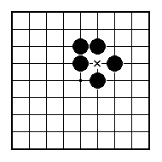
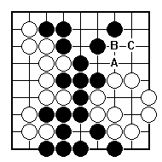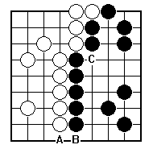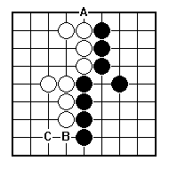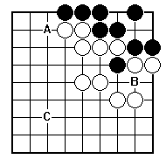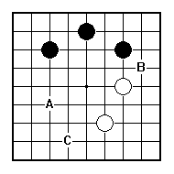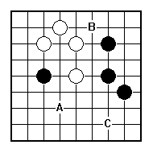
Should Black play A, B or C?

Should White play A, B or C?

Should Black play A, B or C?

Should Black play A, B or C?

Should White play A, B or C?

Should Black play A, B or C?

NAME:
BRITISH GO ASSOCIATION CERTIFICATE LEVEL 3 - SHEET 8

BIG AND SMALL (PART 1)

